Sad Country

Why sad country songs? I’m not sad or depressed. There is something about the emotional response these melodies and lyrics bring forth that makes them appealing. We can all feel what they are saying. I had no particular criteria or process to select these songs other than that they resonate with me.
All arrangements are by me. My process starts by writing down most every note of every instrument. Sometimes I use lead lines or scores from books to start the framework. A few piano parts were from books but most were rewritten by me. All other parts I wrote or played except where noted.
I am grateful for the contributions of my bride, Betsy Popkes, on piano for many of the songs. Thanks for contributions of Andrew Shu on fiddle and Jessie Sweeney on clarinet. Kirk Hanson and Mayrin Rosales are each featured vocalists on songs.
Sad Country has been a work of fun and joy despite the title. Fifteen months of off and on work. (Due to travel and other interests) Hopefully my recording skills got better as well over that time. (The first tune had 12 mixes, the last just two.)
Steve Popkes June 2026

The Players.

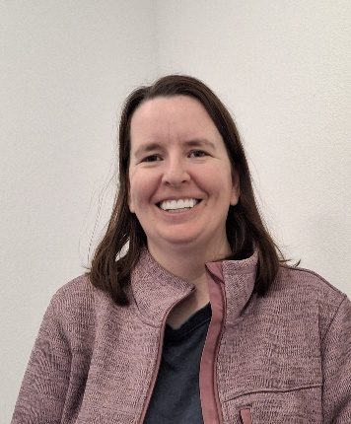

Andrew Shu- Fiddle
Jessie Sweeney- Clarinet
Betsy Popkes - Piano
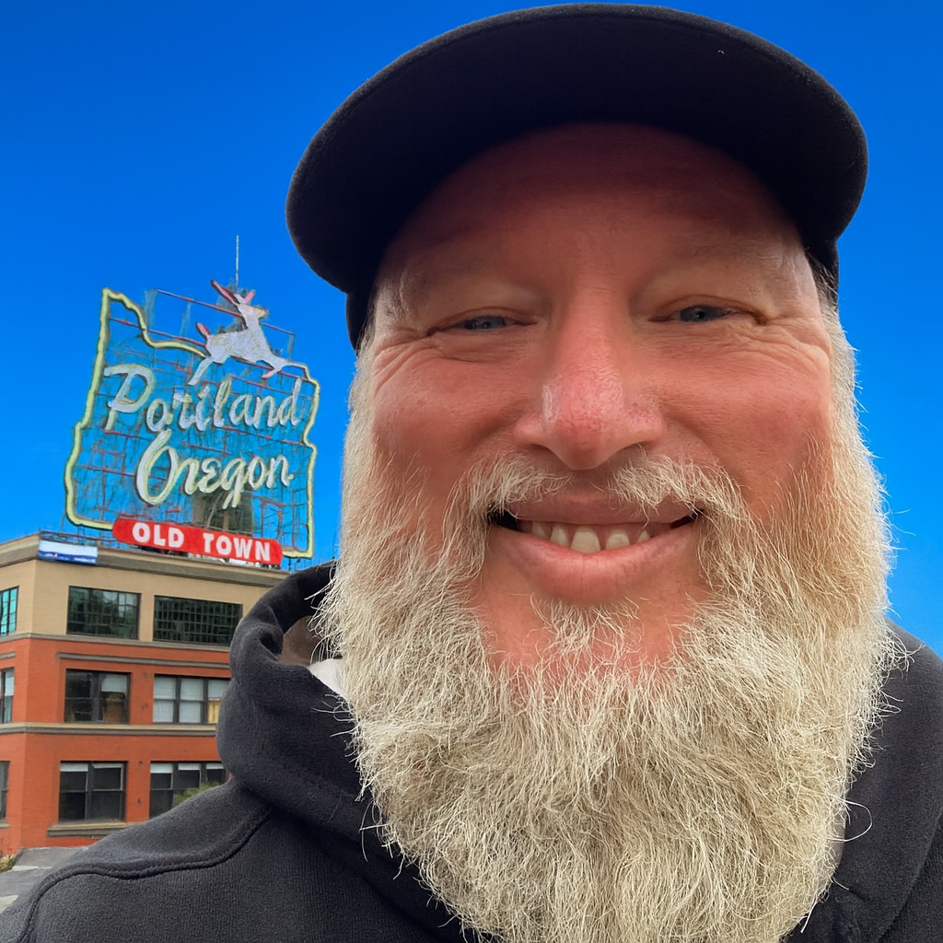

Kirk Hansen- Vocal

01 Tennessee Waltz
Many sad country songs are about lost love. This was one our band, Whiskey and Cigars, used to play. The structure was already in my head. I included all all the verses. (other recordings may not) Piano- Betsy Popkes Fiddle- Andrew Shu
02 Blue Eyes Crying in the Rain
Sometimes I write my own piano accompaniments, because the ones you buy always play the melody. I usually don’t want that. This is one of those. While working on this one our son, Michael Stafford, gifted me a 12string guitar. It was perfect for my vision of verse 2. I borrowed the idea of cello in a country band from the Dixie Chicks. Andrew Shu delivers a great fiddle part.
03 Cold Cold Heart
My observation is most of the old songs from Hank Williams Sr. were sad. They seem to resonate from his heart. Nora Jones recorded a version of this about 25 years ago. It inspired my take. It’s a country song in a blues style. I played it all on this one.
04 Long Black Veil ( A story song)
I first heard this about 25 years ago at a pub in Portland Oregon. I always wanted to cover it. Finally I got there. This is bluegrass style. All played by me. Accordion was fun. And yes cello is not a traditional bluegrass instrument. In traditional bluegrass they all gather around one microphone. I figure it took at least seven if me gathered around that mic.
05 Lucille
A song most of us know. You can’t help but to sing along. In early 2025 I took some piano lessons, thus the basic piano part. I admit midi played some of this. Harmony was fun. Fiddle- Andrew Shu

06 Blue
One of the country swing songs on this album. Vocalist, Mayrin Rosales, brought this to me. It came from my offer to friends who want to try recording. She can really deliver. (Check out our version of Le fe de Maria on You Tube.) Piano- Betsy Popkes Clarinet- Jessie Sweeney Trombones- Steve Popkes In July 2025 I found an old trombone in an antique store. I thought Why Not? Discovered I could still play 40 years later.
07 When I call your Name
A few years ago, I covered Vince Gill’s “Go Rest High on that Mountain” In this case I wanted another Vince Gill tune. This one was on a list of sad country songs. This is part of my attempt at Floyd Cramer style piano. I wrote the part but midi played some of it. Harmonica is really a melodica. (Looks like harmonica with keys)
08 Seven Spanish Angels
Another tune previous covered by Whiskey and Cigars. This is my new arrangement. I find no other recording that includes verse 3. I had to write 2 lines of lyric for that. Good friend, Kirk Hansen, delivers a great performance on this duet. I like the marimba.
09 Crazy
A tune written when Willie Nelson was young! The old TV show, Monk had an episode where Monk played his clarinet along with Willie. I thought, Why Not? Jessie Sweeney delivers on clarinet. I added trombone for extra non-traditional goodness. Thanks Betsy for covering a difficult piano part.
10 Green Green Grass of Home
The last song recorded for this project. I wanted a nod to the Nashville Sound of the 50s and 60s thus the strings. You don’t know it’s a sad song until the end. Piano- Betsy Popkes

